**Motivational Modelling Handout for University of Melbourne students**

**Leon Sterling, Queue Solutions Pty Ltd**

Motivational modelling is used in CIS subjects for three objectives:

* Eliciting project goals using the do/be/feel™ method
* Building a lightweight model from the do/be/feel™ method which constitutes a shared understanding between clients and the team about project goals
* Reporting on progress of the project goals

Background: Motivational models have emerged from fifteen years of research into agent-oriented software engineering at the University of Melbourne and Swinburne University of technology. A motivational model is a model designed to present project goals to clients at an abstract level to facilitate communication between the client and the team. Motivational models are deliberately (and deceptively) simple, a picture on a single page. They are intended to capture a project’s purpose. Our experience with motivational models has taught us that the models can be understood by a wide range of backgrounds and experience. The construction process is lightweight and compatible with agile development methods.

The elicitation method, entitled do/be/feel™, has been used extensively over the last several years in software engineering project subjects at the University of Melbourne, and a range of research projects and consulting projects. Do/be/feel™ identifies the stakeholders of the intelligent socio-technical system, what the system should do or, in more technical words, the functional requirements of the system; how the system should be, which constitute quality requirements of the system; and, what is more novel, how the stakeholders should feel when they interact with the various elements of the socio-technical system. Do/be/feel™ is both a participatory design method and an example of a co-design process.

An example motivational model

An Australian Research Council project ran within CIS at the University of Melbourne from 2008 till 2011 on the question ‘how can grandparents and grandchildren have fun together over the Internet?’ It was an interesting project with a diverse set of researchers including ethnographers, human-computer interaction experts, psychologists and software engineers. How could all the researchers, coming from different disciplines, be on the same page?

We built a motivational model early in the project and used it to orient thinking for the three years of the project. The model helped shape the development of three systems that were prototyped and tested in families during the course of the research project.

The motivational model that the researchers used is useful to give a concrete example. It

is presented in Figure 1. The project began with background research on how families might interact over distance. What would families like to do together? Tell a story, read a book, give a gift, create a memory, or just play. The project conducted an ethnographic study investigating how grandparents and grandchildren at a distance might interact. An analysis showed five main categories of activities: reading, playing, communicating, creating memories, and reminiscing. Sharing pictures was an element of all of communication, creating memories and reminiscing. These are depicted in the parallelograms in the figure which express what the system will do.



Figure 1: A motivational model for remote family engagement

We also need to describe attributes of the system. If grandparents and grandchildren of different backgrounds are to use technology over the Internet, it must be easy-to-use and robust. It should not consume a lot of resources and needs to be easy to maintain. These attributes are contained in the cloud in Figure 1. Note we have several attributes in the single cloud. Previously, we had one non-functional requirement per cloud which increased clutter in the diagram. We have experimented with composite clouds, but currently advocate listing many words in the cloud as demonstrated above. If the list of quality requirements naturally decompose into blocks, separate clouds can be used for each block.

The system allowing grandparent-grandchild interaction also needs to be fun. From a software engineering perspective, being fun is a different type of requirement. It introduces an element of subjectivity and an element of openness. One person’s fun may not be another’s. However the requirement is essential. If the system is not fun to use, it will not be successful. Fun builds on the emotions of its users. In conducting the research study, we uncovered other factors that had an emotional element. Grandparents wanted to be a presence in the lives of their grandchildren, and to display affection in a friendly way. For grandparents and grandchildren, using the technology should build confidence in their abilities. The emotional attributes are given in the heart in Figure 1, again several attributes in the one shape.

Concepts and symbols for motivational models

It is important that a diagram looks good and compelling. Making sure diagrams are effective is more a feature of a design education, rather than a software engineering one. Diagrams need to be easily understood. A ‘big picture’ view of the system and its requirements should be presented. Requirements are typically split into functional and non-functional requirements. Loosely, functional requirements express what the system should do, while non-functional requirements express how the system should be. The requirements ideally are expressed at a high level of detail, though the level of detail at which people feel comfortable varies greatly. People don’t easily go into details. Our research has indicated value in identifying and treating differently one type of non-functional requirements, emotional requirements, which express how stakeholders should feel when interacting with the system. Explicitly addressing emotions is a key addition from previous research. Our research indicates that emotions play a key role in people adopting technology. The icons used in motivational models are presented in Figure 2. Parallelograms represent what the system should do; clouds represent how the system should be, stick figures represent the roles/stakeholders in the system, while hearts, naturally enough, represent the emotions that are trying to be engendered in the stakeholders. The parallelograms, clouds, and hearts are sufficiently wide to fit a reasonable amount of text inside them. Having labels inside nodes works well.



Figure 2: Symbols for Motivational models

One variant we have considered adding are concerns, depicted within an upside-down spade. Concerns are things people try to avoid, for example feeling confused, or differently expressed, avoiding emotional barriers.

We now review the motivational model in Figure 1, depicting how grandparents and grandchildren should interact. The overall goal of the system, as expressed in the diagram is to achieve technology-enabled remote family engagement. The stakeholders, as indicated in the label under the role symbol (the stick figure to the right of the large parallelogram), are grandparents, grandchildren and parents. Parents play a large role in ensuring successful engagement between grandparents and grandchildren.

The heart symbol to the right of the role symbol has five terms, which express the positive emotions that the system will ideally engender in the stakeholders. There should be a feeling of ever-presence of the grandparents in the lives of the grandchildren. The engagement should be affectionate, which admittedly is a challenge in some families. The engagements should build confidence in the participants. The engagement should be both friendly and fun.

The cloud symbol to the left of the large parallelogram also has five terms, which express the qualities of the family engagement. Any technology that is introduced should be easy-to-use. It should be efficient in its use of resources including time and bandwidth, and relatedly should be lightweight. Note that the terms are not completely independent, and how the terms interact will be clarified during system specification and design. Any system should be low maintenance, and robust in being tolerant of mistakes that users will invariably make. One could argue for other qualities, but it would not affect the look-and-feel of the model which are presenting in this chapter.

The overall goal has five lines leading from it. The parallelograms they lead to are effectively five sub-goals of the overall system. In this case, they are modalities whereby families can engage. They should be able to read together remotely, play together, have (lots of) communication, create memories between the stakeholders, and allow stakeholders to reminisce. Several of the modalities should allow the sharing of pictures. Again in practice, this list may be different. Indeed the list is a retro-fit from the University of Melbourne project.

Note that the requirements as expressed in the motivational models are not fully specified. They could be considered ambiguous, but that is the nature of the goals being considered, for example fun. The ability to have fun while reading stories will be interpreted differently by grandparents and grandchildren. Both grandparents and grandchildren want to have fun, but would typically have fun in different ways. Leaving how to allow fun for both grandparents and grandchildren is a design question left up to designers.

The do/be/feel™ method

The do/be/feel™ method is a lightweight, interactive and adaptable way of capturing diverse ideas from a group of people. Typically, conducting do/be/feel™ takes around 30 minutes, though the duration can vary according to circumstance. In our experience, running the method can be as quick as 15 minutes, or occasionally can be stretched over multiple sessions to ensure the inclusion of all stakeholders. We often refer to an elicitation session with do/be/feel™ as a do/be/feel™ workshop.

We highlight three features of the method. One feature is efficiency, the process taking a few hours at most. The efficiency is in contrast with other requirements elicitation methods which rely on transcription and text analysis, and typically take much longer. Another feature of the do/be/feel™ method is that it generates a positive vibe. Trying to describe the emotions desired to be engendered inevitably creates a positive feeling in the room in our experience. Feeling positive encourages participation, and also can encourage later adoption of methods developing from the models. A third feature is that having people think in terms of do/be/feel™ encourages consideration of a high-level view. People attending do/be/feel workshops are steered away from prematurely getting bogged down in low-level details. Getting into the details is a design activity, better left to a different stage of development when people feel more aligned to the purpose.

The essence of the do/be/feel™ method is the generation of four lists: titled who, do, be, and feel. Generating the lists should be a collaborative activity. The items on the lists are essentially the stakeholders of an intended system along with system goals. The ‘who’ list capturing the stakeholders is useful, and typically expands during the elicitation session. Do goals correspond to the functional requirements as discussed in the previous section. Be goals correspond to the system attributes or qualities such as being secure, accessible. In traditional software engineering these goals are often labeled the non-functional requirements. Feel goals list the emotions that the system designers and developers would like to engender in the stakeholders, especially the users who regularly interact with the system. Labelling a list ‘Do goals’ or even more simply ‘Do’ rather than ‘Functional requirements’ creates a more informal and engaged atmosphere, which is better for engaging non-technical people. It helps make the process positive with the people involved in the workshop.

Generating the lists can be done at a small client meeting or at a stakeholder workshop. Do/be/feel™ can also be run by an individual, but it more fun as a social activity, and positive sharing of purpose is positive. It is essential to collaboratively develop purpose in an organization to increase customer involvement and improve the likelihood of customer take up of the resultant system/vision.

It is convenient to generate the four lists on a whiteboard. However large pieces of paper can also work. It is also nice to be multi-coloured. Our preference is to use four differently coloured whiteboard markers. Figure 3 shows the aftermath of a do/be/feel™ workshop, with workshop participants looking at the four whiteboard areas that were filled with lists. The lists are drawn in different colours: black for the ‘who’ list, blue for the do list, green for the be list, and red for the feel list. While it is not essential to have different colours, in our experience, the colours add to the workshop. Switching colours while being a scribe is straightforward. The lists on the whiteboard are recorded at the end of the workshop, typically by taking a photograph on a smart phone.

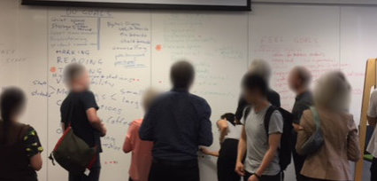

Figure 3: A do/be/feel™ workshop in progress

To make the method concrete, we describe how the method was used developing a motivational model for a non software-based socio-technical system - coming up with a revised space plan for a department at a university. The description is based on real experience, but is simplified in several regards that are not germane to the method. The method was undertaken with some skepticism from some of the stakeholders, and the results exceeded expectations.

We have chosen to demonstrate the do/be/feel™ method with a non-software system for several reasons. Primarily the method is being illustrated with an example to which many, if not most, people can relate – space, which makes for an effective explanation. Designing space for a department is similar to designing space for a home or small business. Providing space at a university is generally contentious due to competing goals and priorities. There is scope to show how conflicting requirements are insightful. Secondarily, using a non-software system shows the generality of the methods being presented in this book. Finally, the scope of the system is sufficient to allow the method to be shown reasonably comprehensively.

The do/be/feel™ method received support from management. The workshop was introduced by the head of department, which helped encourage participation from the people at the workshop. As facilitators, we try to emphasise the lightweight nature of the activities, keep a positive and fun tone, and remind people that the method is based on many years of research. Some people neutral about the activity have become advocates after experiencing the activity.

Let us comment about preparation and setup. There are two key roles – method facilitator and scribe. Both roles can be undertaken by the same person in small workshops. For workshops with a large number of attendants, it is helpful to have a second person recording the ideas in the four lists to ensure elements are captured quickly as they are being called out.

Prior research and experience in the problem domain, including understanding any relevant terminology, is valuable. It is important to ensure that the facilitator is well prepared to understand the workshop discussions. Arrangements need to be made to recruit participants who are able to espouse the requirements for a variety of roles, and that multiple viewpoints of the system are expressed.

One issue that some participants have raised is the potential overlap between elements of the ‘be’ lists and ‘feel’ lists. Indeed the two lists are not entirely separate. A response is that a system feeling secure is not the same as it actually being secure. However, detailed explanation of the difference is not essential. In our experience, overlap does not seem to cause problems during actual workshop. Any overlap between be and feel list elements gets smoothed out in the second stage of the motivational modeling process.

To discuss the running example, the main objective was to improve the departmental space. The workshop was scheduled to last 30 minutes. Participants were department members spanning all organisational levels and roles. We had the support of the Head of the department, which helped in attracting participants to the workshop. At the start of the workshop, the facilitator welcomed participants and explained the purpose of the activity. Next the facilitator described and motivated the four list categories (do, be, feel, who) that had been written as headings on the whiteboard.

Participants were reminded about the lists. Do goals correspond to functional requirements. Be goals correspond to quality requirements. Feel goals correspond to the emotional needs of the stakeholders. Roles correspond to any stakeholder involved in the system. The activity differs from a usual software engineering requirements elicitation process where emotional considerations are not typically considered.

After the introduction the facilitator encouraged the participants to contribute items for each category, prompting people as necessary. In our project, the facilitator asked participants (i) what they wanted to do in the space, (ii) how they wanted the space to be, (iii) how they wanted to feel in the space, and (iv) who would use the space. The scribe captured the goals, writing them under the associated category in the assigned colour. The facilitator clarifies terms that s/he did not understand. No fixed order between lists was imposed.

The period of contributions follows a standard brainstorming approach in that ideas should not be filtered out. The activity ends when participants cannot think of new items to add to the lists. In practice, there is no strict order and the conversation can flow organically between categories.

To demonstrate the output of do/be/feel™, here is a version of the four lists generated from one of the workshop with staff. The list elements are straightforward.

Who list: *Academics; Professional staff; Students; Guests; Collaborators; Curators*

Do list: *Improve departmental space; Promote positive culture; Meet students; Meet each other; Host external guests; Have lunch; Have coffee; Socialize; Network; Support academic activities; Write papers and reports; Read papers and reports; Display work in spaces; Visualize work on whiteboard; Store reports; Display reports*

Be list: *Active; Fertile; Happening; Lived in; Semi-structured; Serendipitous; Informal; Engaging; Flexible; Silent; Peaceful; Informal*

Feel list: *Honest; Comfortable; In control; Welcoming; Connected; Productive; Visible*

An optional final activity of a do/be/feel workshop is to prioritise the items in the lists. Any lean technique can be used, for instance dot voting (http://dotmocracy.org/dot-voting/ ). Each participant is assigned a finite number of dots that they can assign to any of the items in the list based on their perceived importance. Rather than using peel-off dots, markers can be given to participants to mark their assigned dots next to the idea on the whiteboard. Prioritisation is a quick method to capture a rough idea of which items are important while all participants are familiar with all group-generated ideas. The number of dots assigned is a judgment call but typically we allow for 5-7 dots per participant.

To close the activity, the facilitator thanks everyone for their time and contributions and captures the results on the whiteboard. It is explained that once the results have been processed, the participants will be invited back to review the model and will be given the opportunity to give feedback and provide any further clarifications.

From Lists to a Model

The second part of motivational modelling is converting the lists generated from a do/be/feel™ elicitation session into a single page model. There are loosely seven steps in the process: review of the lists generated by the do/be/feel method, clustering the elements in the lists, structuring the elements from the do list into a hierarchy, attaching the elements from the remaining lists (be, feel, and who) to the hierarchy, and then reviewing the resultant motivational model with key stakeholders. We talk about each of the seven steps in the context of the running example of improving space. Note that subjective judgments are required in most of the steps, which may result in different people constructing different motivational models from the same input. The subjectivity has not been a problem in our experience. Motivational models are primarily useful for communication and articulating a common purpose. Indeed the steps involved in the process involve several instances where discussion is encouraged to ensure all stakeholders are aligned. Ambiguities will be resolved later in the design and development process. Motivational models are a description not a specification, and are ideal to encourage a high level view.

**Step 1**: *Review the lists*

Motivational model construction begins with reviewing the four lists from the do/be/feel™ method. Items which were clear during the elicitation session can seem disconnected on later review. Implicit relationships within or between the lists are easily forgotten. The review is ideally led by the facilitator of the do/be/feel™ workshop who may be able to elaborate on confusing aspects of the lists based on discussions held during the workshop. Any questions, ambiguities, differing interpretations or assumptions should be noted for later clarification with attendees at the workshop.

Items to be checked in a review include any duplicated elements, elements that should be broken into sub-elements, or redundant elements. Rewording elements may happen to maintain consistency. Following certain conventions, if possible, when naming goals improves clarity. We suggest wording functional goals, the elements of the do list, as active constructions starting with a verb; wording quality goals, the be list elements, as attributes of the system as adjectives or adjectivised sentences; and also wording emotional goals, feel list elements, as adjectives. The list of roles should require little modification.

As a small example of a review step, two of the goals in the do list are ‘have coffee’ and ‘socialise.’ During the do/be/feel workshop, the item written down was ‘have coffee and socialize.’ The decision was taken to split them into two goals as they are not entirely the same.

**Step 2**: *Cluster the contents of the lists*

The second step is a clustering activity to group related elements together. How to cluster will depend on how the lists have been constructed. When the workshop attendees all have similar perspectives, the clustering can be almost self-evident.

Let us illustrate an instance from the departmental space example where subjective judgment is required for clustering. Two elements from the do list are ‘have lunch’ and ‘have coffee.’ The social aspects of having a coffee and eating lunch together are similar but not identical. It seems sensible to include them in the same cluster as their space needs can be similar. Judgment is then needed as to whether the two elements should be combined as a single goal ‘have lunch/coffee,’ or as two separate goals. There is no correct answer, which works better may depend on the context.

In another example from the running example, we suggest combining the two elements storing reports and displaying reports into a single node. Storing reports requires different physical spaces. However the handling of reports can be considered a minor factor compared with ensuring that the space is productive for academic activities. Having one goal associated with reports rather than two is a subjective judgment intended to downplay the importance of consideration of reports.

For simple lists, clustering can be done on an ad-hoc basis. Subsequently checking with the client usually results in agreement of how the clusters should look. For lengthier lists, especially when many more people have been involved, ad-hoc methods are strained.

The do/be/feel™ method has been run in lecture theatres for a group of 70 students where each student has added items to each of the do, be and feel lists on sticky notes. Clearly, with over a hundred items to assemble, a more systematic approach is needed. Affinity diagrams are s good technique to follow to create the clusters. To create an affinity diagram, the team would write (or assemble) the elements from each list on sticky notes of four different colours, each representing one of the list categories. The sticky notes would then be grouped into clusters of related elements. The grouping activity makes it easy to visualise the clusters that are heavier in emotional, quality or functionality aspects, or what clusters involve multiple stakeholders. Figure 4 shows clustering from the department space example.

Multiple instances of the same goal or role may appear in different clusters. For repeated roles, qualities or emotions, this indicates participation of the role in more than one functionality of the system, or that a particular consideration is more important for a certain functionality. Repeated functional goals are harder to justify and will trigger further questions for the client. Once clustering is completed, a label is chosen for each cluster. Ideally, a representative functional goal that already exists within each cluster could be nominated for this purpose. Otherwise, a new functional goal should be created that encompasses all elements in the cluster.

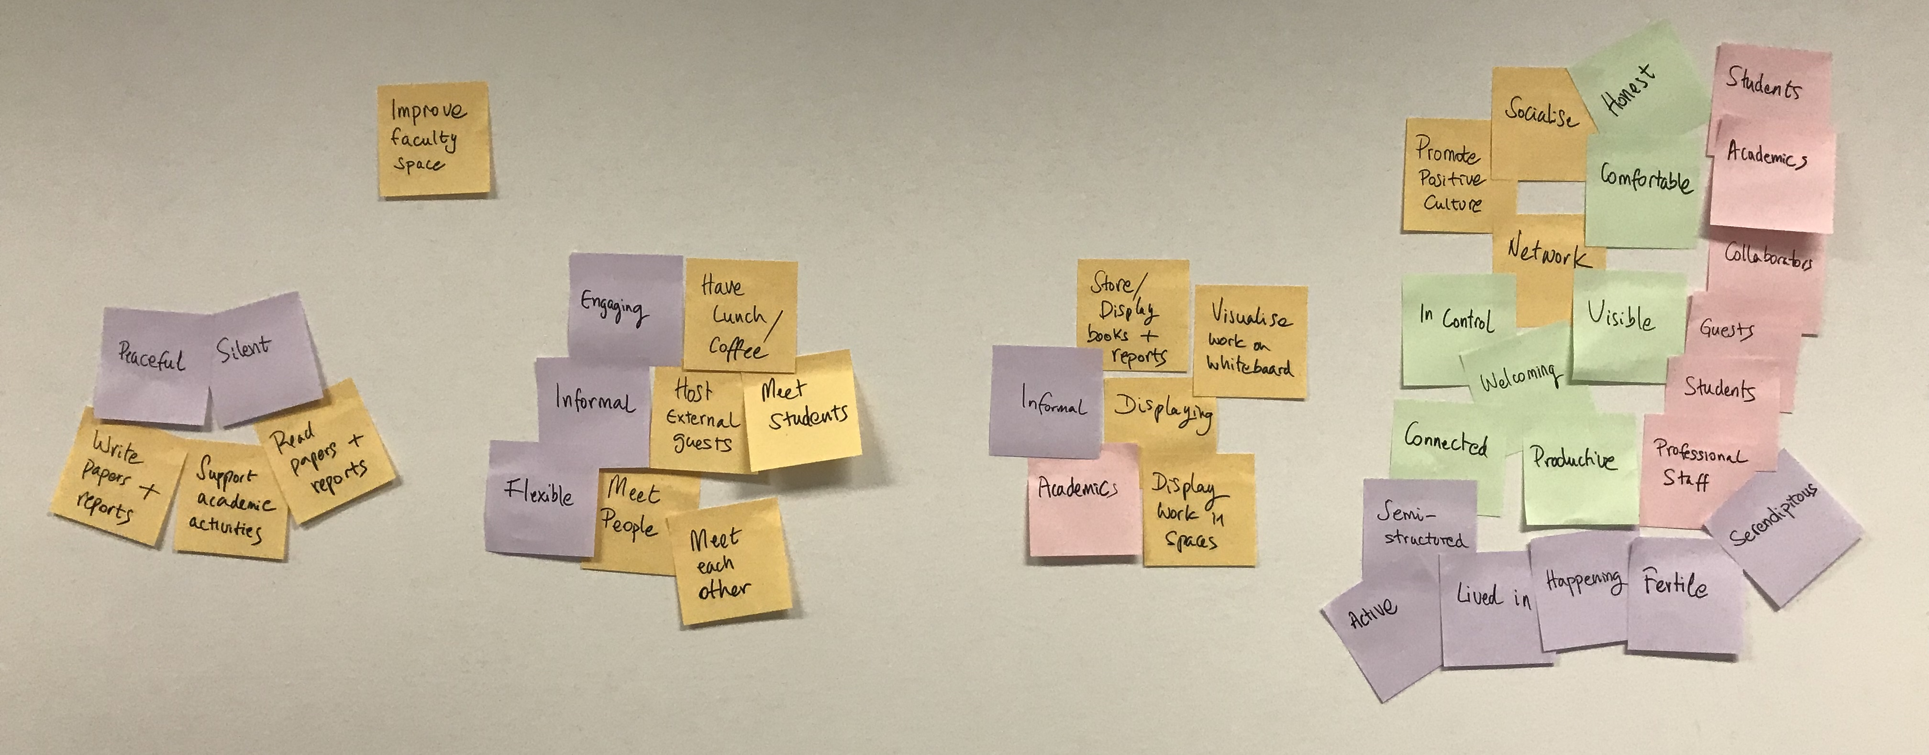

Figure 4: Clustering of elements for departmental meeting space from a do/be/feel workshop

In the running example, the list elements were reviewed by the people responsible for requirements analysis and four clusters were formed (see Figure 4). Each cluster represented elements associated with promoting positive culture, displaying, meeting people, and supporting academic activities. Elements within the ‘support academic activities’ cluster provoked questions as it was unclear whether these activities were intended to be individual or group-based. As the answer to this distinction affected the clustering it was noted for later clarification with the client.

We find that additional questions that are revealed from building the model provoke discussion and solidify understanding. The output is a motivational model that provides a high-level overview of the system goals that can be used as a lightweight communication tool with stakeholder organisations and between members of the development team.

**Step 3**: *Establish a hierarchy from the do list elements in the form of a tree*

As shown in the example in Figure 1, motivational models are (annotated) upside-down trees. It is important to focus on the (larger) node which is the root of the tree to get an initial understanding of what the model in the diagram is conveying. Having a hierarchy to look at trains one’s vision. To establish the structure of the motivational model, a hierarchical view of do list elements (functional goals) is built. Subsequently goals in the functional hierarchy are associated with corresponding roles, quality goals and emotional goals.

*Step 3a Identify the root of the tree*

Step 3 contains three sub steps. The first one, labeled step 3a, is to identify the root of the tree. The root should summarise the purpose of the motivational model, and is the overarching, and perhaps most important, goal. Sometimes the overarching goal has been identified during do/be/feel™ elicitation. Indeed an experienced facilitator of a do/be/feel™ workshop will be looking for what the overarching goal might be. It may well be the tag line for an organization or project, which may have been developed in a separate exercise.

In the case of the departmental space example, the overall goal is to improve the space. A major reason for wanting to improve the space was to promote a positive culture in the department. It is a question as to whether the overarching goal should be ‘improve departmental space’ or ‘promote a positive culture.’ Resolving the overall purpose is clearly a discussion which needs to happen with the client, who may in turn want to have the discussion with all of the stakeholders.

Step 3b *Build sub trees*

Each cluster identified in Step 2 will be represented by a branch of the tree. Every functional goal within the cluster is examined to determine the cluster’s hierarchical structure. Clusters that have only one functional goal will result in a single-element branch under the main overarching purpose. For multiple element hierarchies, the top-level functional goal (or root) will be the functional goal that we selected (or created) in the previous stage to represent the cluster. An effective way of establishing the functional goal hierarchy (both at cluster level and overall system level) is the application of How/Why Laddering (https://dschool-old.stanford.edu/groups/k12/wiki/afdc3/HowWhy Laddering.html).

In essence, given a hierarchy of functional goals, the sub-goals detail how the parent goal is achieved, the parent goal explains why its sub-goals are necessary. For instance, let us look at a fragment of our running example shown in Figure 3. One mid-level goal is to Promote Positive Culture. One answer to the question ‘how do we promote positive culture?’ could be by meeting people. Similarly, one reason for why we want to meet people is because we want to promote positive culture.

At the start of step 3, there should be a set of disconnected sub-trees. The next step is to join them together into one hierarchical structure. A suitable functional goal should be chosen (or created) to be the root functional goal. It will become the parent of the entire model. If each hierarchy cluster corresponds to a unique aspect of the system (i.e. there is no hierarchy relation between them) then all clusters may be situated under the root functional goal. Further structural amendments may be required. For instance, goals that crosscut many other goals may be more suited as their parent goal, and consequently could be raised up in the hierarchy. In other instances, some functional goals may need to be duplicated across multiple sub-trees, and possibly renamed to reflect the distinction (clarification with the client will ensue). Building the hierarchy is an iterative process that is complete once a clear and meaningful structure is obtained.

For the running example we first considered the Meet People cluster and the functional goals within it. The functional goals that belonged to this cluster (e.g. meet students, meet each other) were all considered to be directly sub-functional relative to the Meet People goal and consequently depicted as such in the figure. A similar process and result was performed to identify the hierarchy for the remaining three clusters.

We then decided that high-level goals corresponding to the three clusters were distinct and should be positioned as three separate functional goals underneath the root goal. These three goals were Meet People, Support Academic Activities, and Displaying Design Artifacts. The fourth goal, Promote Positive Culture was different as it crosscuts the other three goals. In fact, promoting a positive culture was a reason why the three other high-level goals were being supported in the meeting space. Consequently, this was positioned as the new root goal and above the previous root Improve Departmental Space. The resulting hierarchy is shown in Figure 5.

Step 3c *Decide on the order of the sub trees*

What should be the order of the three subgoals Meet People, Support Academic Activities, and Displaying Design Artifacts? This is another subjective decision. Support academic activities is the most characteristic activity of a department. It is natural to place it leftmost as we scan diagrams from left to right, at least when reading. Meeting people is very important, and thus placed next to support academic activities. Finally displaying design artifacts becomes the rightmost goal.

Over the years we have been careful not to define a rigid semantics to the order of the goals. Being too prescriptive is an impediment for a high level understanding. Having a natural flow when presenting and explaining the motivational model is something we try and accomplish when contemplating the order of the branches of the tree.

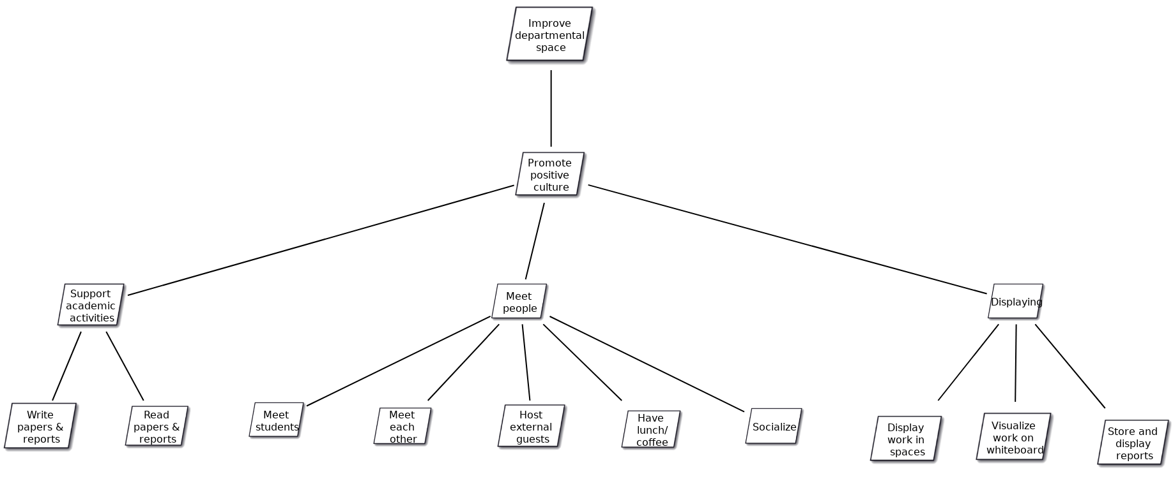Figure 5: Do goal hierarchy for the space example

Step 4: *Add elements from the who list*

Each stakeholder in the who list needs to be considered as to where it should be attached to the functional hierarchy developed in the previous step. We refer to stakeholders as roles here. If a role is responsible for achieving a goal, then it needs to be associated with the goal or a goal higher in the hierarchy. Associations can be shown with visual proximity, as additional connectors such as lines or arrows add unnecessary clutter and make the model cognitively taxing for readers.

If a role is associated to a functional goal, then it is also associated to its corresponding sub-functional goals. A key consideration is the level of granularity of the role. Keeping the pairing at a high-level can indicate a broad relationship to many aspects of the system. Differently, pinpointing a role to a low-level goal can bring a contextual focus to part of the solution. In any case, placing a role should be a deliberate decision and should intend to reflect a meaningful piece of information about the system.

If several roles are associated with a functional goal, they can be listed under a single role icon. Figure 1 illustrates multiple roles in a single role icon, where grandparents, grandchildren and parents are all involved in ensuring that the remote family engagement happens and is fun. Listing several roles under one icon as opposed to having several icons reduces visual clutter.

In our running example, several roles, such as the role of an academic, are associated with every functional goal. These roles are placed near to the root goal in Figure 5. Roles which are only associated with some functional goals are placed further down in the model hierarchy next to the relevant goals. For instance, family members of the department are interested in meeting people and enjoying the displays of the work, but do not perform academic activities themselves. Similarly, curators of work displays are only interested in the displaying functional goal and this association is presented in the model.

Step 5: *Add elements from the be list*

Once the roles have been attached to the hierarchy of the do elements, we attach the quality goals expressed as elements in the be list. The next step is attaching the emotional goals expressed as elements in the feel list. Whether we consider quality goals before emotional goals is arbitrary and indeed when modeling it is possible to do both steps concurrently. For clarity of exposition, we consider the quality goals first. For that matter it is not a mistake to attach quality goals before roles. Sometimes it is helpful to address roles first as the quality goals may depend not only on the functional goals but may also be associated to specific roles.

For each element in the be list and functional goal in the hierarchy, we consider whether the quality goal represented by the be list element is important while achieving the functional goal. If yes, the quality goal should be associated with the functional goal. It is likely that a quality goal will apply to more than one functional goal. If this is the case, it is correct to duplicate the quality goal. If a quality goal has an impact on all the functional goals at the same level (in practice, roots of separate sub-trees), that quality goal should possibly be placed in the parent functional goal of those instead.

For instance, following with our running example depicted in Figure 2.6, all the sub-goals of supporting academic activities, i.e. reading and writing papers, should be done in silence. Therefore, the quality goals silent and peaceful should qualify the parent functional goal, Support Academic Activities.

For the sake of simplicity of notation, we suggest grouping as many quality goals inside a cloud shape as practical. It is key to avoid overloading the diagram with notation, so non-technical stakeholders can understand it. Too many disparate elements confuse the diagram. Previously we have had a separate cloud for each quality and it was arguably less clear than grouping them together.

Step 6: *Add elements from the feel list*

To add the emotional goals, we proceed similarly as for the quality goals, but with one distinction. For the emotional goals, it is relevant to distinguish the role who wants to feel like that (emotional goal) in relation to the functional goal. In this sense, emotional goals are related to both a functional goal and a role.

Consider that there may be more than one role involved in a functional goal, and their emotional needs may be very different. For each emotional goal, role and functional goal in a cluster hierarchy, we consider whether the role wants to feel this emotion for this functional goal. A positive answer means that the emotional goal is placed between the functional goal and the role involved. Similarly as for quality goals, it should be considered whether emotional goals should be applied to sub-goals or if it is warranted that they are moved to a parent level. Also, similarly to the quality goals, it is likely that emotional goals will need to be duplicated in various branches. For instance, in the example shown in Figure 6, we can see that everyone using the new space wants to feel productive and comfortable, among others.

As for quality goals, we suggest grouping as many emotional goals as practical inside the heart shape for the sake of simplicity of notation.

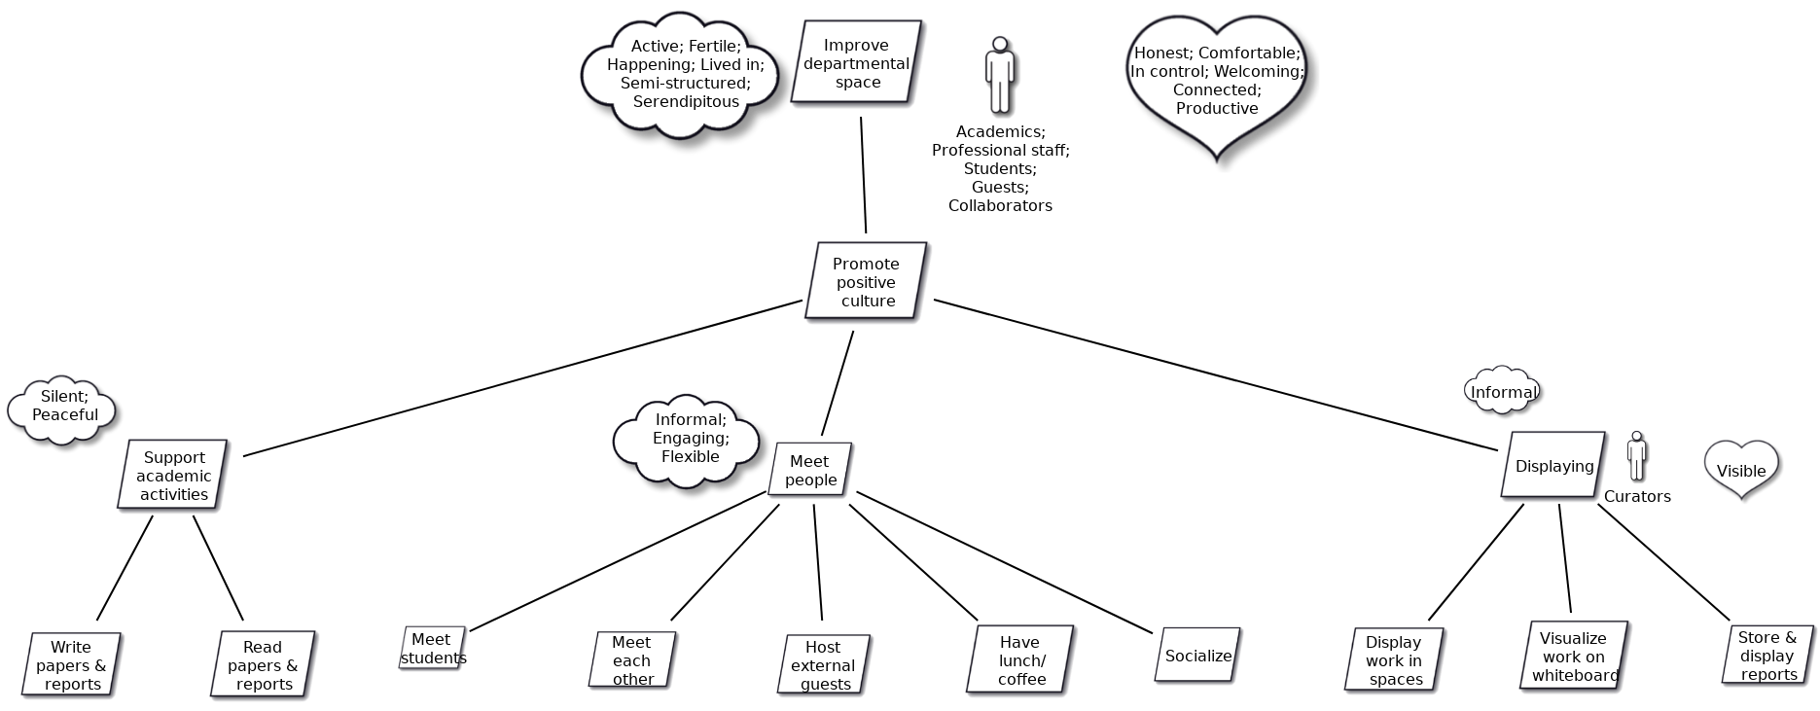

Figure 6: A motivational model for departmental space

Step 7: *Revise the model with key stakeholders*

The initial draft of the motivational model needs to be reviewed, by as wide a range of stakeholders as possible. Usually, the review is done for the primary client of the project. Ideally the person who developed the motivational model should present his/her understanding of the system by verbally walking through the motivational model, explaining the notations as appropriate. The review with the client is an excellent opportunity to receive feedback on any aspect of the socio-technical system including how it has been modeled, or other entity being modeled. Any clarifications that have been collected during the model building steps should be presented.

A useful first step is to ask for any more thoughts about the who/do/be/feel lists since the workshop. In that respect it is useful to have access to the old lists during the review meeting. In our experience, there are usually no more additions to the lists, at least initially. Checking for additions and not finding many reinforces the impression that the previous process was comprehensive.

The discussion should be structured in a top-down manner and cover each element in the model. Feedback from the client could indicate a missing element (incompleteness), or an inconsistency. Feedback from the client is an essential step in the process and should be noted, with the model amended subsequently. Clarifications that are being sought can be flagged by an appropriate annotation to the motivational model so that it gets asked during the presentation to the client.

Any changes lead to improved understanding of the system and its representation in the motivational model. At the end of the session, there should be agreement that both clients and modellers are ‘on the same page’. The modellers gain feedback from the client that will be incorporated in the next version of the model. The process of presenting to the client and updating the model iterates until no more changes are required by the client.

Another form of review can happen if not everyone was present at the original do/be/feel workshop. People can look at the model and suggest additional elements to any of the four lists. Having whimsical parallelograms, clouds, and hearts for people to write additions on can add to a positive impression of understanding the system. This was the case with the departmental space motivational model which went through several rounds of improvement both from the client and other stakeholders.

Motivational modelling tool

CIS at the University of Melbourne has made available a tool to make it easy to record the results of a do/be/feel™ workshop, and build a motivational model by drag and drop. A manual for the tool will be available through the LMS.

Three versions of the tool being hosted.

SWEN90009 students should log on to

<http://momo-swen90009.eresearch.unimelb.edu.au/>

Your unimelb username and password should work. You have been assigned to your team group.

SWEN90013 students should log on to

<http://momo-swen90013.eresearch.unimelb.edu.au/>

Your unimelb username and password should work. You have been assigned to your team groups. The team names are team1 to team10 and numbers correspond to the alphabetical order.

Other students should log on to

<https://momo-staging.eresearch.unimelb.edu.au/>

You will need to register as a user, and send an email to [leonss@unimelb.edu.au](mailto:leonss@unimelb.edu.au)

You will then be assigned to a team.